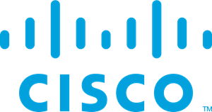

Lab 1 Windows Format and Install
By: Alen Sheen
P6-7
Objective:
The goal of this lab was to install and set up Windows 11 on new computers for our Cisco CCNP labs. We needed to make sure they had all the necessary software installed, like Putty for network access and Lenovo tools to keep the system running smoothly.
Background Information:
Setting up a new computer is more than just turning it on—it requires installing an operating system (OS) and important software to make sure everything works correctly. The OS is basically what allows you to do anything on a computer; without it, the hardware just sits there. For this lab, we went with Windows 11 Education, a version of Windows 11 designed for schools. It comes with some extra features that are great for learning environments and better security, which is important when you're connecting to networks or working with sensitive data.
Windows 11 is the latest from Microsoft and brings a lot of updates compared to Windows 10. Some highlights include:
- Better Security: Windows 11 has improved security features like TPM 2.0 and secure boot, making it harder for hackers or viruses to mess with the system.
- Improved Multitasking: Tools like Snap Layouts let you organize multiple windows more easily, which is useful when you’re working on several things at once.
- Performance Boosts: It’s designed to run faster and more efficiently, which helps with demanding tasks like those we’ll face in our Cisco labs.
Aside from the OS, we needed tools like Putty for remote access to Cisco devices. Putty is a simple terminal emulator we’ll use to connect to routers and switches in future labs. It’s lightweight and easy to use, which makes it a solid choice for these tasks.
We also installed Lenovo Commercial Vantage and Lenovo Service Bridge, two apps that help manage and maintain the computers. They help keep the system up to date and ensure it runs smoothly—kind of like regular checkups for the computer to make sure everything’s in order.
Lastly, we set up Office 365 for productivity tools like Word, Excel, and PowerPoint, as well as OneDrive for cloud storage. This helps us collaborate on projects and keep everything in sync across devices.
In a nutshell, this background isn’t just about installing Windows 11; it’s about preparing these machines for all the work they’ll be handling in our Cisco labs, making sure they’re secure, and equipping them with the tools we need for everyday use.
Lab Summary:
In this lab, I installed Windows 11 Education, set up the system, and added key software to get the computers ready for our Cisco CCNP labs.
Setup Overview:
- Boot Menu Access:
  - Insert the Windows 11 installation USB drive.
  - Restart the computer and press F12 to enter the Boot Menu.
  - Select the USB drive as the boot device to start the installation process
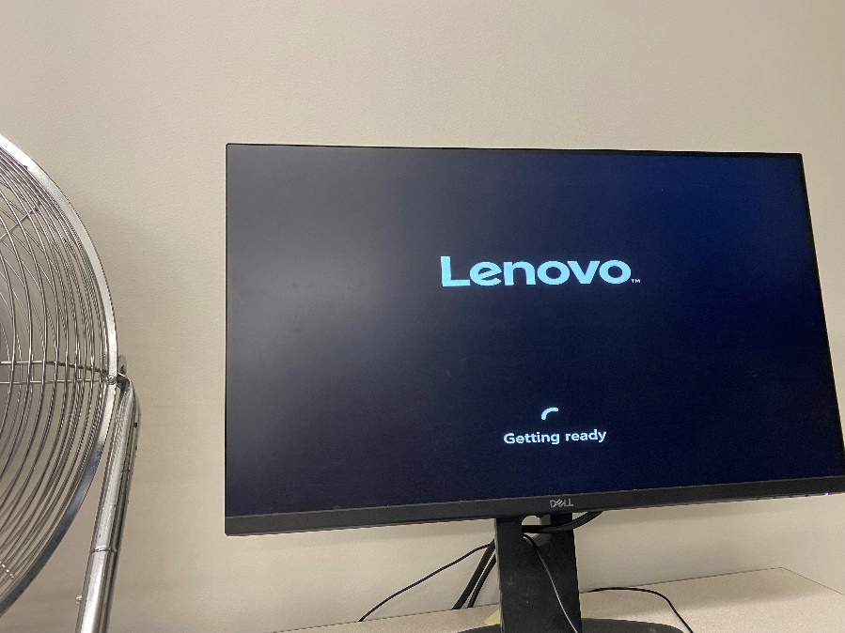
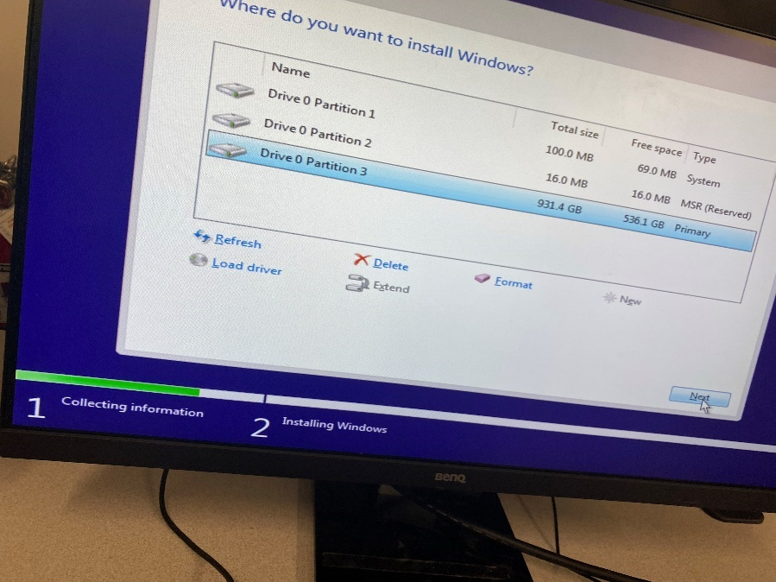
- Windows 11 Installation:
  - Choose Windows 11 Education as the version to install.
  - Set up language, time, and keyboard preferences.
  - Follow the installation steps and complete the initial setup (like Wi-Fi and user preferences).
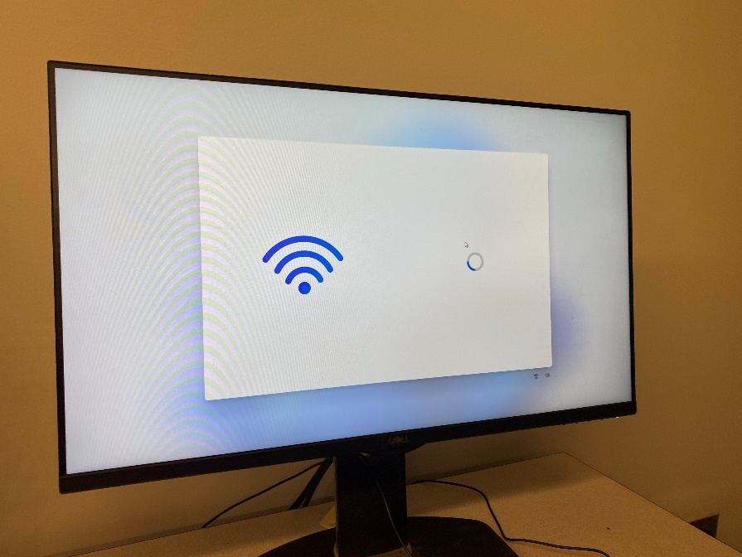
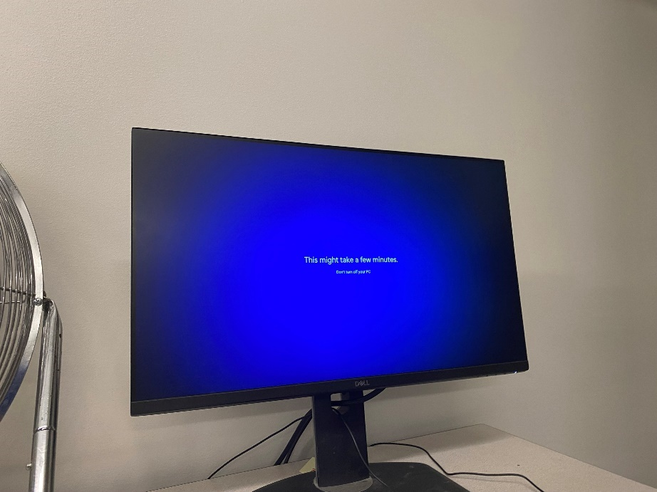
- Software Installation:
  - Lenovo Commercial Vantage: Installed to optimize system performance.
  - Lenovo Service Bridge: Helps with automatic updates and keeping the system in good health.
  - Putty: Installed as our go-to tool for connecting to Cisco devices in future labs.
  - Office 365: Installed for productivity and collaboration tools.
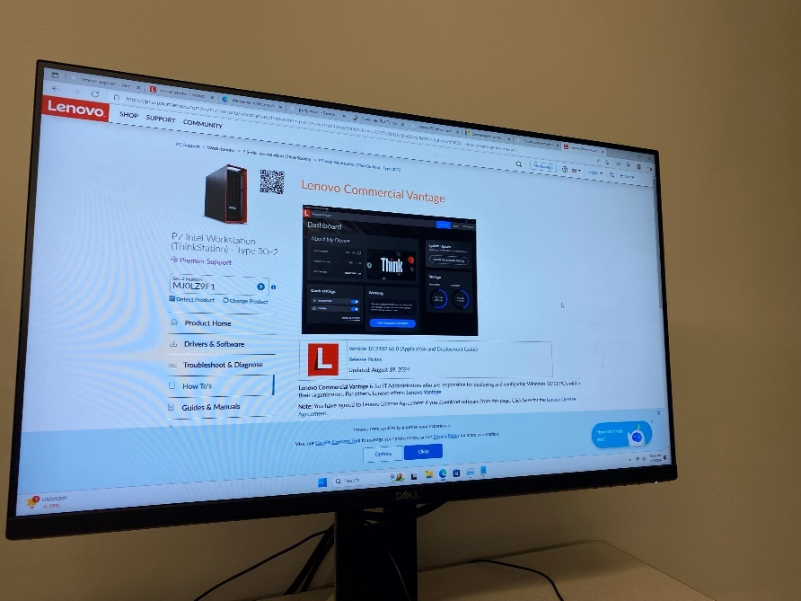
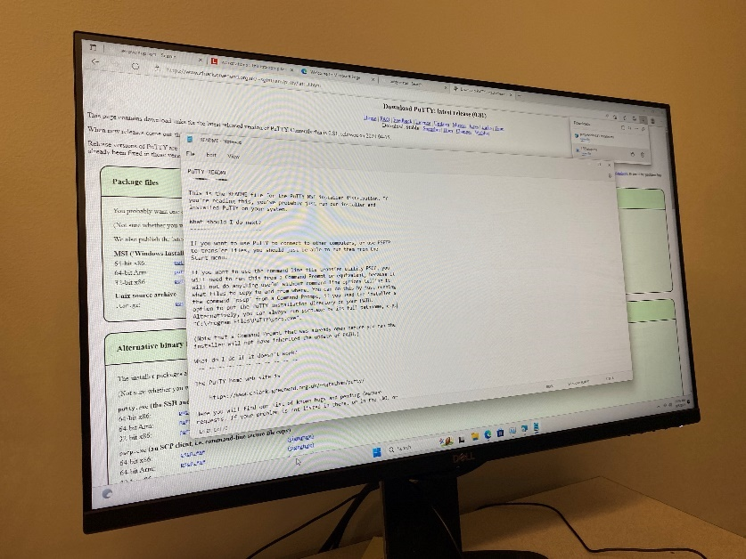
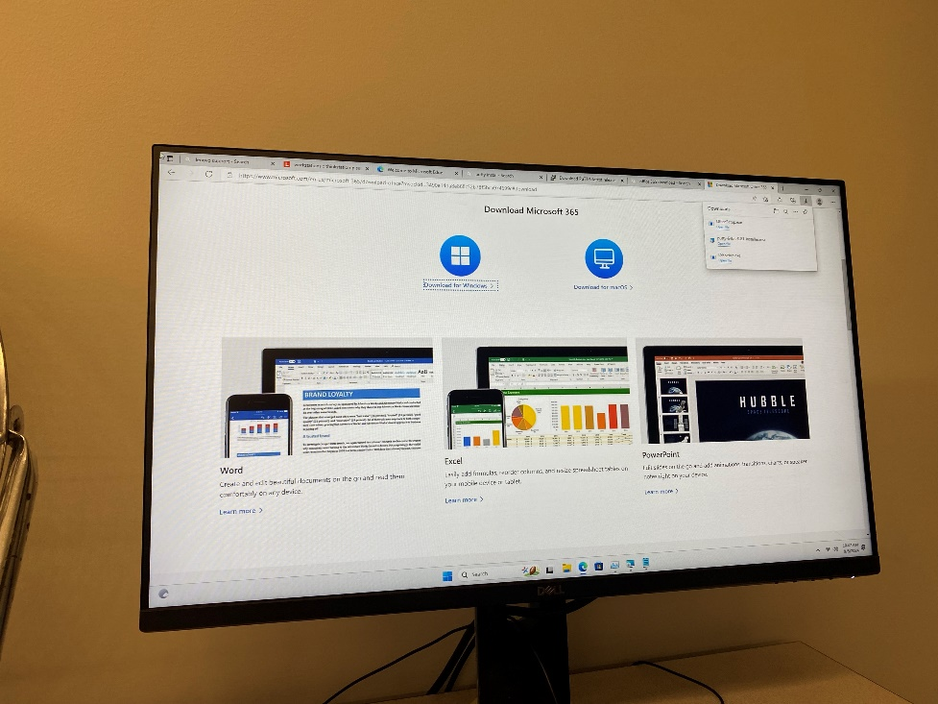
- Security Setup:
  - Enabled Windows Firewall and other security features to protect the system from unauthorized access.
Lab Commands:
- Access Boot Menu:
  - Restart the computer and press F12 to open the Boot Menu.
  - Select the USB drive to start installing Windows.
- Set Up Windows:
  - Follow the setup prompts for region, language, and keyboard settings.
  - Proceed with the Windows 11 installation.
- Network Setup:
  - Connect to Wi-Fi during the initial setup.
  - After installation, make sure all security features are enabled.
- Install Applications:
  - Install Lenovo tools, Putty, and Office 365 using their respective installers.
Problems Encountered:
I ran into a few challenges while setting everything up:
- Boot Issues: At first, I couldn’t get the computer to boot from the USB drive. After a couple of restarts and tweaking the BIOS settings, I managed to fix it.
- Slow Software Installation: Programs like Office 365 took a while to install, mostly because of the large file sizes and slow internet.
- Network Confusion: I wasn’t sure if I should connect to Wi-Fi during the initial setup, but after talking with a classmate, I realized it was better to wait until after security settings were configured.
Conclusion:
This lab gave me a good look at what it’s like to set up a computer from scratch. Installing Windows 11 and configuring all the necessary apps was a hands-on way to learn how things work behind the scenes, especially since most of the devices I’ve used in the past came pre-set. I learned how to navigate BIOS, install an OS, and add software, which will definitely come in handy when we start working with Cisco devices in future labs.
It was a rewarding experience, and I now have a better understanding of how the system setup impacts the performance and functionality of the computers we’ll be using. I'm looking forward to putting these skills to use in future labs and troubleshooting network setups in the real world.

